**TEFF GRASS**

**CROP SAFETY**

**EVALUATION**

**MARCO PENA**

April 29, 2022 Aplication done

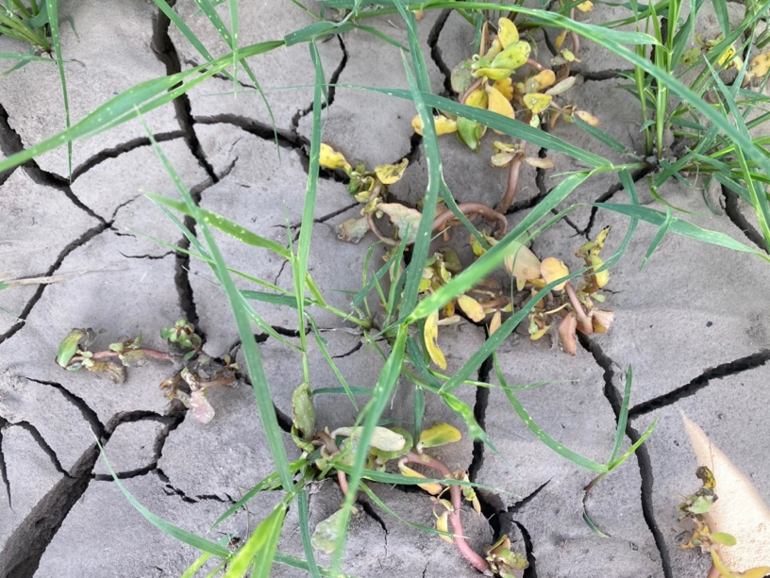

Banvel 3day evaluation

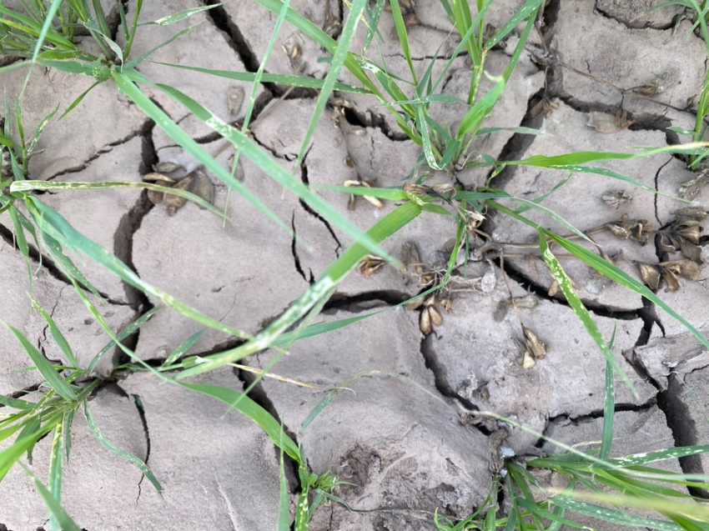

ET herbicide 3day

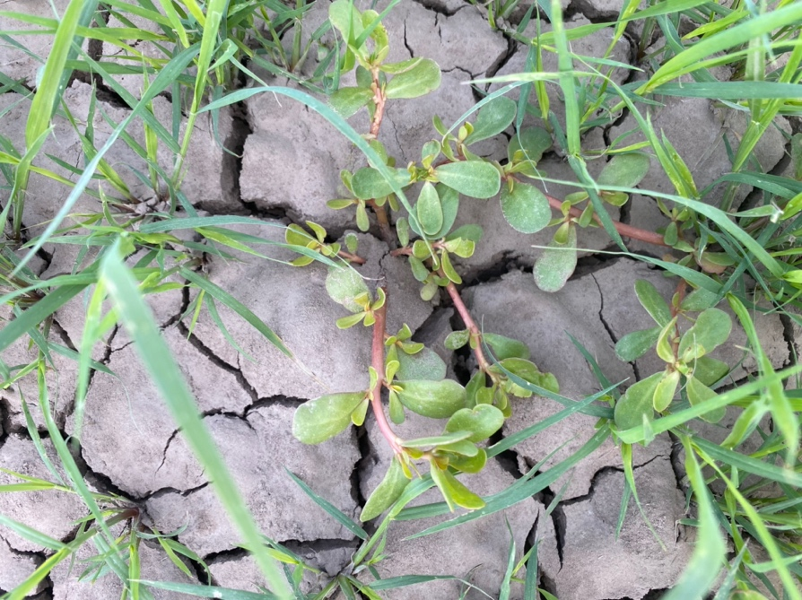

Simplicity 2x (3day)

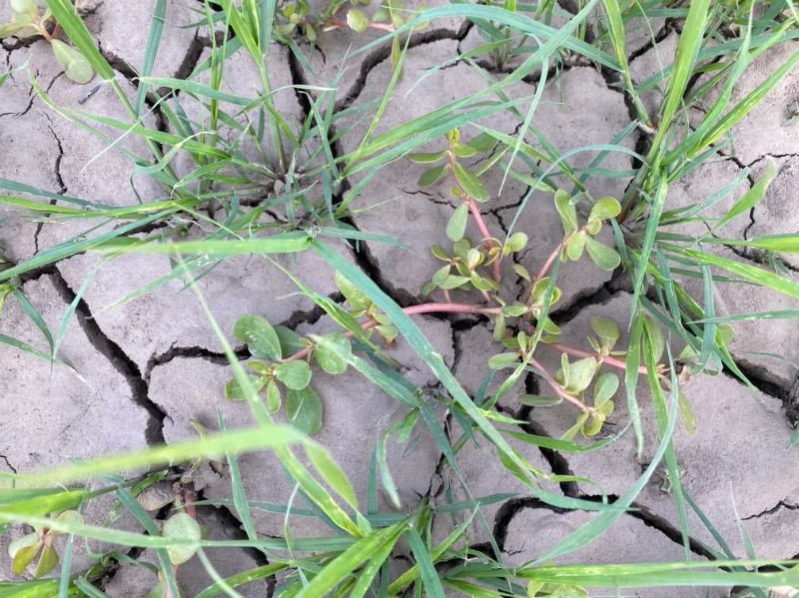

Osprey 3day

Simplicity 1x (3day)

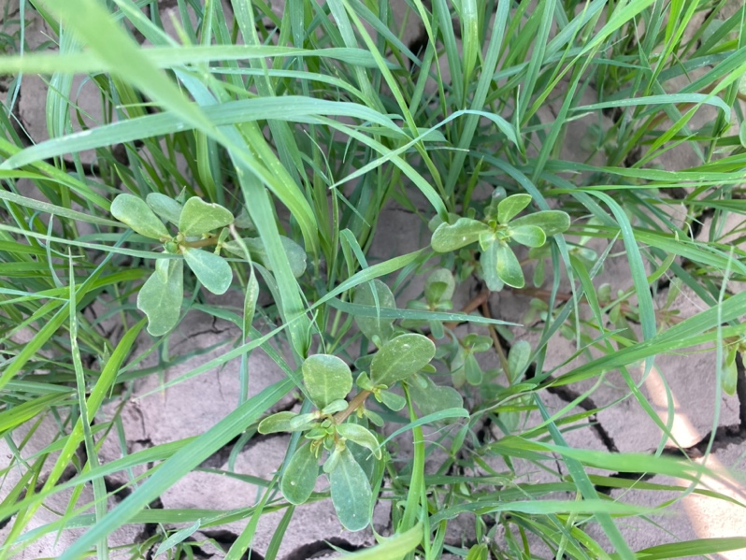

UTC

Osprey 15 day

By May 20 almost all plots recovered except Osprey plots. (21Day)

Grower cut avoiding experiment on May 7, 2022. At the time of cutting Trt 1 still presented phyto and was about 4” shorter than UTC.

May-26-2022 (2022 Teff Grass Evaluation) ARM 2022.2 AOV Means Table Page 1 of 5

**University of Arizona**

**2022 Simplicity Evaluation**

|  |  |  |  |  |  |  |
| --- | --- | --- | --- | --- | --- | --- |
| Trial ID: | 2022 Simplicity Evaluation | Location: |  |  | Trial Year: | 2022 |
| Protocol ID: |  | Investigator (Creator): | Marco Pena | |  |  |
| Project ID: |  | Study Director: |  |  |  |  |
|  |  | Sponsor Contact: |  |  |  |  |

|  |  |  |  |  |  |  |  |  |  |  |  |  |  |  |
| --- | --- | --- | --- | --- | --- | --- | --- | --- | --- | --- | --- | --- | --- | --- |
| Pest Type | | | | |  | | W, Weed | |  | | W, Weed | |  | |
| Pest Name | | | | |  | | Common purslane | |  | | Common purslane | |  | |
| Crop Name | | | | | Eragrostis tef | | Eragrostis tef | | Eragrostis tef | | Eragrostis tef | | Eragrostis tef | |
| Rating Date | | | | | May-2-2022 | | May-2-2022 | | May-6-2022 | | May-6-2022 | | May-12-2022 | |
| Part Rated | | | | | plant, - | | plant, - | | plant, - | | plant, - | | plant, - | |
| Rating Type | | | | | PHYGEN | | % Control | | PHYGEN | | % Control | | PHYGEN | |
| Number of Subsamples | | | | | 1 | | 1 | | 1 | | 1 | | 1 | |
| Data Entry Date | | | | | May-19-2022 | | May-20-2022 | | May-20-2022 | | May-20-2022 | | May-20-2022 | |
| ARM Action Codes | | | | |  | |  | |  | |  | |  | |
| Trt | Treatment |  | Rate | Appl | 1 | | 2 | | 3 | | 4 | | 5 | |
| No. | Name | Rate | Unit | Code |  | |  | |  | |  | |  | |
| 1 | Simplicity | 6.75 | fl oz/a | A | 10.00 | a | 6.25 | c | 5.00 | b | 27.5 | b | 10.0 | c |
|  | Activator 90 | 0.5 | % v/v | A |  |  |  |  |  |  |  |  |  |  |
| 2 | Simplicity | 13.5 | fl oz/a | A | 12.50 | a | 6.88 | c | 8.13 | a | 36.3 | b | 13.8 | b |
|  | Activator 90 | 0.5 | % v/v | A |  |  |  |  |  |  |  |  |  |  |
| 3 | Osprey | 4.75 | oz/a | A | 11.25 | a | 6.25 | c | 10.63 | a | 11.3 | c | 18.8 | a |
|  | Activator 90 | 0.5 | % v/v | A |  |  |  |  |  |  |  |  |  |  |
| 4 | ET | 2.0 | fl oz/a | A | 5.63 | b | 100.00 | a | 3.13 | b | 100.0 | a | 0.0 | d |
|  | Silicone spreader | 3 | fl oz/100 gal | A |  |  |  |  |  |  |  |  |  |  |
| 5 | Banvel | 0.5 | pt/a | A | 0.00 | c | 88.75 | b | 0.00 | c | 97.5 | a | 0.0 | d |
|  | 80/20 | 0.5 | % v/v | A |  |  |  |  |  |  |  |  |  |  |
| 6 | Untreated Check |  |  |  | 0.00 | c | 0.00 | d | 0.00 | c | 0.0 | d | 0.0 | d |
| LSD P=.05 | | | | | 3.635 | | 2.504 | | 2.535 | | 9.86 | | 3.18 | |
| Standard Deviation | | | | | 2.412 | | 1.661 | | 1.682 | | 6.54 | | 2.11 | |
| CV | | | | | 36.75 | | 4.79 | | 37.56 | | 14.4 | | 29.76 | |
| Levene's F^ | | | | | 1.119 | | 0.811 | | 0.832 | | 1.471 | | 0.80 | |
| Levene's Prob(F) | | | | | 0.386 | | 0.557 | | 0.544 | | 0.248 | | 0.564 | |
| Skewness^ | | | | | -0.5894 | | -0.7798 | | 0.5912 | | -0.1006 | | -0.3004 | |
| Kurtosis^ | | | | | 0.6819 | | 1.4516 | | 1.0719 | | 0.0767 | | 0.7363 | |
|  | | | | |  | |  | |  | |  | |  | |
| Replicate F | | | | | 1.358 | | 2.358 | | 1.074 | | 1.916 | | 1.563 | |
| Replicate Prob(F) | | | | | 0.2934 | | 0.1127 | | 0.3900 | | 0.1704 | | 0.2398 | |
| Treatment F | | | | | 21.466 | | 3124.925 | | 26.374 | | 174.429 | | 61.125 | |
| Treatment Prob(F) | | | | | 0.0001 | | 0.0001 | | 0.0001 | | 0.0001 | | 0.0001 | |

Means followed by same letter or symbol do not significantly differ (P=.05, LSD).

t=Mean descriptions are reported in transformed data units, and are not de-transformed.

Mean comparisons performed only when AOV Treatment P(F) is significant at mean comparison OSL.

^Calculated from residual.

d=Means are reported in de-transformed data units

May-26-2022 (2022 Teff Grass Evaluation) ARM 2022.2 AOV Means Table Page 2 of 5

**University of Arizona**

**2022 Simplicity Evaluation**

|  |  |  |  |  |  |  |
| --- | --- | --- | --- | --- | --- | --- |
| Trial ID: | 2022 Simplicity Evaluation | Location: |  |  | Trial Year: | 2022 |
| Protocol ID: |  | Investigator (Creator): | Marco Pena | |  |  |
| Project ID: |  | Study Director: |  |  |  |  |
|  |  | Sponsor Contact: |  |  |  |  |

|  |  |  |  |  |  |  |  |  |  |  |  |  |  |  |
| --- | --- | --- | --- | --- | --- | --- | --- | --- | --- | --- | --- | --- | --- | --- |
| Pest Type | | | | | W, Weed | |  | |  | |  | |  | |
| Pest Name | | | | | Common purslane | |  | |  | |  | |  | |
| Crop Name | | | | | Eragrostis tef | | Eragrostis tef | | Eragrostis tef | | Eragrostis tef | | Eragrostis tef | |
| Rating Date | | | | | May-20-2022 | | May-2-2022 | | May-6-2022 | | May-20-2022 | | May-20-2022 | |
| Part Rated | | | | | plant, - | | plant, - | | plant, - | | plant, - | | plant, - | |
| Rating Type | | | | | % Control | | HEIGHT | | HEIGHT | | HEIGHT | | PHYGEN | |
| Number of Subsamples | | | | | 1 | | 5 | | 5 | | 5 | | 1 | |
| Data Entry Date | | | | | May-20-2022 | | May-20-2022 | | May-20-2022 | | May-20-2022 | | May-20-2022 | |
| ARM Action Codes | | | | |  | |  | |  | |  | | AS | |
| Trt | Treatment |  | Rate | Appl | 6 | | 7 | | 8 | | 9 | | 10 | |
| No. | Name | Rate | Unit | Code |  | |  | |  | |  | | dAS | |
| 1 | Simplicity | 6.75 | fl oz/a | A | 99.5 | a | 7.78 | c | 8.70 | b | 21.2 | bc | 0.0 | c |
|  | Activator 90 | 0.5 | % v/v | A |  |  |  |  |  |  |  |  |  |  |
| 2 | Simplicity | 13.5 | fl oz/a | A | 99.5 | a | 7.43 | c | 8.08 | bc | 20.5 | c | 3.9 | b |
|  | Activator 90 | 0.5 | % v/v | A |  |  |  |  |  |  |  |  |  |  |
| 3 | Osprey | 4.75 | oz/a | A | 97.5 | a | 7.33 | c | 7.50 | c | 16.4 | d | 12.4 | a |
|  | Activator 90 | 0.5 | % v/v | A |  |  |  |  |  |  |  |  |  |  |
| 4 | ET | 2.0 | fl oz/a | A | 100.0 | a | 9.38 | b | 12.10 | a | 22.1 | ab | 0.0 | c |
|  | Silicone spreader | 3 | fl oz/100 gal | A |  |  |  |  |  |  |  |  |  |  |
| 5 | Banvel | 0.5 | pt/a | A | 98.8 | a | 10.20 | a | 12.40 | a | 22.4 | a | 0.0 | c |
|  | 80/20 | 0.5 | % v/v | A |  |  |  |  |  |  |  |  |  |  |
| 6 | Untreated Check |  |  |  | 0.0 | b | 10.20 | a | 12.75 | a | 22.5 | a | 0.0 | c |
| LSD P=.05 | | | | | 2.55 | | 0.744 | | 0.901 | | 1.03 | | 1.35 - 2.06 | |
| Standard Deviation | | | | | 1.69 | | 0.494 | | 0.598 | | 0.68 | | 0.20t | |
| CV | | | | | 2.05 | | 5.67 | | 5.83 | | 3.27 | | 13.98t | |
| Levene's F^ | | | | | 2.895 | | 0.467 | | 0.568 | | 1.341 | | 16.214 | |
| Levene's Prob(F) | | | | | 0.043* | | 0.796 | | 0.724 | | 0.292 | | 0.00* | |
| Skewness^ | | | | | -0.7642 | | 0.5192 | | -0.1138 | | -0.3378 | | 0.0 | |
| Kurtosis^ | | | | | 1.5204 | | 0.8764 | | -0.0115 | | -0.1073 | | 0.1113 | |
|  | | | | |  | |  | |  | |  | |  | |
| Replicate F | | | | | 0.790 | | 0.068 | | 2.568 | | 2.840 | | 1.000 | |
| Replicate Prob(F) | | | | | 0.5179 | | 0.9759 | | 0.0932 | | 0.0733 | | 0.4199 | |
| Treatment F | | | | | 2284.880 | | 30.577 | | 64.869 | | 45.825 | | 146.151 | |
| Treatment Prob(F) | | | | | 0.0001 | | 0.0001 | | 0.0001 | | 0.0001 | | 0.0001 | |

Means followed by same letter or symbol do not significantly differ (P=.05, LSD).

t=Mean descriptions are reported in transformed data units, and are not de-transformed.

Mean comparisons performed only when AOV Treatment P(F) is significant at mean comparison OSL.

^Calculated from residual.

d=Means are reported in de-transformed data units

May-26-2022 (2022 Teff Grass Evaluation) ARM 2022.2 AOV Means Table Page 3 of 5

**University of Arizona**

**2022 Simplicity Evaluation**

|  |  |  |  |  |  |  |
| --- | --- | --- | --- | --- | --- | --- |
| Trial ID: | 2022 Simplicity Evaluation | Location: |  |  | Trial Year: | 2022 |
| Protocol ID: |  | Investigator (Creator): | Marco Pena | |  |  |
| Project ID: |  | Study Director: |  |  |  |  |
|  |  | Sponsor Contact: |  |  |  |  |

Pest Type

W, Weed = Weed or volunteer crop

Rating Type

PHYGEN = phytotoxicity - general / injury

HEIGHT = height

ARM Action Codes

AS = Automatic square root transformation of X+0.5

|  |  |  |  |  |  |  |  |  |  |  |
| --- | --- | --- | --- | --- | --- | --- | --- | --- | --- | --- |
| Pest Type | | | | | |  | W, Weed |  | W, Weed |  |
| Pest Name | | | | | |  | Common purslane |  | Common purslane |  |
| Crop Name | | | | | | Eragrostis tef | Eragrostis tef | Eragrostis tef | Eragrostis tef | Eragrostis tef |
| Rating Date | | | | | | May-2-2022 | May-2-2022 | May-6-2022 | May-6-2022 | May-12-2022 |
| Part Rated | | | | | | plant, - | plant, - | plant, - | plant, - | plant, - |
| Rating Type | | | | | | PHYGEN | % Control | PHYGEN | % Control | PHYGEN |
| Number of Subsamples | | | | | | 1 | 1 | 1 | 1 | 1 |
| Data Entry Date | | | | | | May-19-2022 | May-20-2022 | May-20-2022 | May-20-2022 | May-20-2022 |
| ARM Action Codes | | | | | |  |  |  |  |  |
| Trt | Treatment |  | Rate | Appl |  |  |  |  |  |  |
| No. | Name | Rate | Unit | Code | Plot | 1 | 2 | 3 | 4 | 5 |
| 1 | Simplicity | 6.75 | fl oz/a | A | 101 | 10.00 | 5.00 | 5.00 | 25.0 | 15.0 |
|  | Activator 90 | 0.5 | % v/v | A | 205 | 7.50 | 5.00 | 5.00 | 30.0 | 10.0 |
|  |  |  |  |  | 303 | 10.00 | 7.50 | 5.00 | 30.0 | 5.0 |
|  |  |  |  |  | 405 | 12.50 | 7.50 | 5.00 | 25.0 | 10.0 |
| Mean = | | | | | | 10.00 | 6.25 | 5.00 | 27.5 | 10.0 |
| 2 | Simplicity | 13.5 | fl oz/a | A | 102 | 10.00 | 7.50 | 7.50 | 50.0 | 15.0 |
|  | Activator 90 | 0.5 | % v/v | A | 201 | 15.00 | 5.00 | 10.00 | 30.0 | 15.0 |
|  |  |  |  |  | 301 | 10.00 | 7.50 | 5.00 | 45.0 | 10.0 |
|  |  |  |  |  | 402 | 15.00 | 7.50 | 10.00 | 20.0 | 15.0 |
| Mean = | | | | | | 12.50 | 6.88 | 8.13 | 36.3 | 13.8 |
| 3 | Osprey | 4.75 | oz/a | A | 103 | 10.00 | 7.50 | 10.00 | 25.0 | 20.0 |
|  | Activator 90 | 0.5 | % v/v | A | 203 | 15.00 | 5.00 | 15.00 | 5.0 | 20.0 |
|  |  |  |  |  | 304 | 5.00 | 10.00 | 7.50 | 10.0 | 20.0 |
|  |  |  |  |  | 406 | 15.00 | 2.50 | 10.00 | 5.0 | 15.0 |
| Mean = | | | | | | 11.25 | 6.25 | 10.63 | 11.3 | 18.8 |
| 4 | ET | 2.0 | fl oz/a | A | 104 | 5.00 | 100.00 | 2.50 | 100.0 | 0.0 |
|  | Silicone spreader | 3 | fl oz/100 gal | A | 204 | 5.00 | 100.00 | 2.50 | 100.0 | 0.0 |
|  |  |  |  |  | 302 | 7.50 | 100.00 | 5.00 | 100.0 | 0.0 |
|  |  |  |  |  | 401 | 5.00 | 100.00 | 2.50 | 100.0 | 0.0 |
| Mean = | | | | | | 5.63 | 100.00 | 3.13 | 100.0 | 0.0 |
| 5 | Banvel | 0.5 | pt/a | A | 105 | 0.00 | 90.00 | 0.00 | 100.0 | 0.0 |
|  | 80/20 | 0.5 | % v/v | A | 206 | 0.00 | 85.00 | 0.00 | 95.0 | 0.0 |
|  |  |  |  |  | 306 | 0.00 | 90.00 | 0.00 | 95.0 | 0.0 |
|  |  |  |  |  | 404 | 0.00 | 90.00 | 0.00 | 100.0 | 0.0 |
| Mean = | | | | | | 0.00 | 88.75 | 0.00 | 97.5 | 0.0 |
| 6 | Untreated Check |  |  |  | 106 | 0.00 | 0.00 | 0.00 | 0.0 | 0.0 |
|  |  |  |  |  | 202 | 0.00 | 0.00 | 0.00 | 0.0 | 0.0 |
|  |  |  |  |  | 305 | 0.00 | 0.00 | 0.00 | 0.0 | 0.0 |
|  |  |  |  |  | 403 | 0.00 | 0.00 | 0.00 | 0.0 | 0.0 |
| Mean = | | | | | | 0.00 | 0.00 | 0.00 | 0.0 | 0.0 |

May-26-2022 (2022 Teff Grass Evaluation) ARM 2022.2 Assessment Data Summary Page 4 of 5

**University of Arizona**

**2022 Simplicity Evaluation**

|  |  |  |  |  |  |  |
| --- | --- | --- | --- | --- | --- | --- |
| Trial ID: | 2022 Simplicity Evaluation | Location: |  |  | Trial Year: | 2022 |
| Protocol ID: |  | Investigator (Creator): | Marco Pena | |  |  |
| Project ID: |  | Study Director: |  |  |  |  |
|  |  | Sponsor Contact: |  |  |  |  |

|  |  |  |  |  |  |  |  |  |  |  |
| --- | --- | --- | --- | --- | --- | --- | --- | --- | --- | --- |
| Pest Type | | | | | | W, Weed |  |  |  |  |
| Pest Name | | | | | | Common purslane |  |  |  |  |
| Crop Name | | | | | | Eragrostis tef | Eragrostis tef | Eragrostis tef | Eragrostis tef | Eragrostis tef |
| Rating Date | | | | | | May-20-2022 | May-2-2022 | May-6-2022 | May-20-2022 | May-20-2022 |
| Part Rated | | | | | | plant, - | plant, - | plant, - | plant, - | plant, - |
| Rating Type | | | | | | % Control | HEIGHT | HEIGHT | HEIGHT | PHYGEN |
| Number of Subsamples | | | | | | 1 | 5 | 5 | 5 | 1 |
| Data Entry Date | | | | | | May-20-2022 | May-20-2022 | May-20-2022 | May-20-2022 | May-20-2022 |
| ARM Action Codes | | | | | |  |  |  |  | AS |
| Trt | Treatment |  | Rate | Appl |  |  |  |  |  |  |
| No. | Name | Rate | Unit | Code | Plot | 6 | 7 | 8 | 9 | 10 |
| 1 | Simplicity | 6.75 | fl oz/a | A | 101 | 100.0 | 7.80 | 9.10 | 21.8 | 0.0 |
|  | Activator 90 | 0.5 | % v/v | A | 205 | 98.0 | 8.00 | 9.20 | 21.8 | 0.0 |
|  |  |  |  |  | 303 | 100.0 | 8.10 | 8.70 | 19.8 | 0.0 |
|  |  |  |  |  | 405 | 100.0 | 7.20 | 7.80 | 21.4 | 0.0 |
| Mean = | | | | | | 99.5 | 7.78 | 8.70 | 21.2 | 0.0d |
| 2 | Simplicity | 13.5 | fl oz/a | A | 102 | 100.0 | 7.40 | 8.60 | 20.6 | 3.0 |
|  | Activator 90 | 0.5 | % v/v | A | 201 | 98.0 | 7.70 | 8.30 | 21.0 | 5.0 |
|  |  |  |  |  | 301 | 100.0 | 6.80 | 7.00 | 20.8 | 5.0 |
|  |  |  |  |  | 402 | 100.0 | 7.80 | 8.40 | 19.6 | 3.0 |
| Mean = | | | | | | 99.5 | 7.43 | 8.08 | 20.5 | 3.9d |
| 3 | Osprey | 4.75 | oz/a | A | 103 | 95.0 | 7.40 | 7.00 | 15.8 | 10.0 |
|  | Activator 90 | 0.5 | % v/v | A | 203 | 95.0 | 7.50 | 7.80 | 17.4 | 15.0 |
|  |  |  |  |  | 304 | 100.0 | 7.50 | 8.00 | 16.2 | 10.0 |
|  |  |  |  |  | 406 | 100.0 | 6.90 | 7.20 | 16.2 | 15.0 |
| Mean = | | | | | | 97.5 | 7.33 | 7.50 | 16.4 | 12.4d |
| 4 | ET | 2.0 | fl oz/a | A | 104 | 100.0 | 8.70 | 13.60 | 21.2 | 0.0 |
|  | Silicone spreader | 3 | fl oz/100 gal | A | 204 | 100.0 | 9.20 | 11.60 | 23.6 | 0.0 |
|  |  |  |  |  | 302 | 100.0 | 9.20 | 11.80 | 21.8 | 0.0 |
|  |  |  |  |  | 401 | 100.0 | 10.40 | 11.40 | 21.8 | 0.0 |
| Mean = | | | | | | 100.0 | 9.38 | 12.10 | 22.1 | 0.0d |
| 5 | Banvel | 0.5 | pt/a | A | 105 | 100.0 | 10.40 | 12.80 | 21.8 | 0.0 |
|  | 80/20 | 0.5 | % v/v | A | 206 | 100.0 | 10.20 | 12.60 | 22.2 | 0.0 |
|  |  |  |  |  | 306 | 95.0 | 10.30 | 11.80 | 23.2 | 0.0 |
|  |  |  |  |  | 404 | 100.0 | 9.90 | 12.40 | 22.4 | 0.0 |
| Mean = | | | | | | 98.8 | 10.20 | 12.40 | 22.4 | 0.0d |
| 6 | Untreated Check |  |  |  | 106 | 0.0 | 10.90 | 13.60 | 22.6 | 0.0 |
|  |  |  |  |  | 202 | 0.0 | 9.90 | 12.40 | 23.2 | 0.0 |
|  |  |  |  |  | 305 | 0.0 | 10.00 | 12.40 | 22.4 | 0.0 |
|  |  |  |  |  | 403 | 0.0 | 10.00 | 12.60 | 21.6 | 0.0 |
| Mean = | | | | | | 0.0 | 10.20 | 12.75 | 22.5 | 0.0d |

Figure 1.

Application was done on April 29, 2022. The chart above shows that Banvel (Dicamba) and the UTC (Untreated control) did not present symptoms of phytotoxicity. The herbicide ET (Pyraflufen) showed low levels of phyto in the first two evaluations consisting of burning of the tips of the crop but then disappeared by the third evaluation not causing stunting of the crop. Simplicity at 6.75 floz/a (in the chart Simplicity 1) presented 10, 5, and 10% phytotoxicity in the 5/2, 5/6, and 5/12 evaluations which also sows in the plant height evaluations. Something similar occurred with the 13.5 floz rate with 12.5, 8.3, and 13.8 phyto. The symptoms disappeared in most of the plots by day 21 after treatment except for the Osprey plots, with a 11.5, 10.63, 18.8, and 12.4 % phytotoxicity on the 21DAT evaluation.

Figure 2.

On the 3 and 7day evaluations Simpliicity 6.75floz was ~2.4 and 4 inches shorter than the UTC. By the 21day height evaluations this treatment was 1.3” smaller. The 13.5 floz rate was 2.77, 4.67, and 2” shorter at the 3, 7, and 21DAT. In all cases the diference was statistically significant.

The Osprey plots presented more stunting. As can be seen in the chart the plots were 2.87, 5.25, and 6.1 inches smaller than the UTC at 3, 7, and 21 days respectively.

ET and Banvel heights were statistically similar to the UTC.

Figure 3.

As can be seen in the chart above Simplicity worked slower than ET or Banvel and by the 21 day evaluation all treatments controlled almost 100% of the purslane.